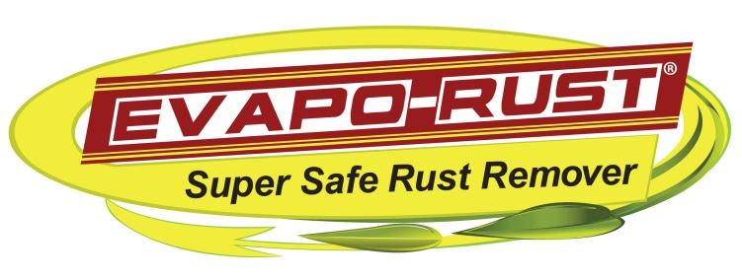

How It Works
EVAPO-RUST works through selective chelation. This is a process in which a large synthetic molecule forms a bond with metals and holds them in solution. Most chelating agents bind many different metals. The active ingredient in EVAPO-RUST bonds to iron exclusively.
It can remove iron from iron oxide but is too weak to remove iron from steel where the iron is held much more strongly. Once the chelating agent has removed the iron, a sulfur bearing organic molecule pulls the iron away from the chelator and forms a ferric sulfate complex which remains water soluble. This frees the chelating agent to remove more iron from rust.

How To Use
Step 1: In a container, pour a sufficient amount of EVAPO-RUST to completely cover the rusted object.
Step 2: Immerse the rusty object in the solution and leave it for 10 minutes for light rust or up to overnight for extremely heavy rust.
Step 3: When finished, rinse item with water. If deep rust remains in pits, re-immerse item until all the rust is gone. Un-rusted metal will not be affected.
NOTE: This stage is VERY important in getting the best results
Step 4: To prevent flash rusting, dip the item back into solution. Then allow item to air dry. This will prevent rust for up to two weeks.

